

***An Internship report submitted by***

**PENUKONDA SHANMUKHA – URK20CS1077**

**NETHIKUNTLA HEMANTH – URK20CS2077**

***in partial fulfillment for the award of the degree of***

**BACHELOR OF TECHNOLOGY**

***in***

**COMPUTER SCIENCE AND ENGINEERING**

***under the supervision of***

**Dr. Esther Daniel**

**Mr. Srivatsa Sinha**



**DIVISION OF COMPUTER SCIENCE AND ENGINEERING**

**KARUNYA INSTITUTE OF TECHNOLOGY AND SCIENCES**

(Declared as Deemed to be University under Sec-3 of the UGC Act, 1956)

**Karunya Nagar, Coimbatore - 641 114. INDIA**

**SMART PHONE PRICE PREDICTION**

**Team name: SH**

**Team Members**

The project was carried out by the following team members:

1) Penukonda Shanmukha - [penukondashanmukha@karunya.edu.in](mailto:penukondashanmukha@karunya.edu.in)

2) Nethikuntla Hemanth - [nethikuntlahemanth@karunya.edu.in](mailto:nethikuntlahemanth@karunya.edu.in)

**Mentor**

We would like to express our gratitude to our mentors for providing guiding and support the internship:

1) Dr.Esther Daniel(Academic mentor) - [estherdaniel@karunya.edu.in](mailto:estherdaniel@karunya.edu.in)

2) Mr.Srivatsa Sinha(Industry mentor)- [srivatsasinha@theprograms.in](mailto:srivatsasinha@theprograms.in)

**Abstract**

The rapid evolution of Smartphone market presents lot of challenges for both consumers and manufacturers. One of major challenge is accurately predicting smart phone prices, which can greatly help consumer purchasing decisions and guide the pricing strategies. This abstract presents a study of predicting smart phone prices using machine learning techniques.

Proposed models involve a comparison and analysis of various machine learning algorithms for price prediction, including regression-based models and deep learning approaches. The study of comprehensive dataset consisting of various features related to smart phones, such as hardware specifications, brand reputation and market trends. The dataset encompasses a wide range of smart phones from different features, price segments.

The research follows a flow of systematic methodology, starting with data preprocessing and feature engineering to have a quality of the dataset. Multiple machine learning models are trained, tested, and evaluated using appropriate performance metrics to evaluate their effectiveness in predicting smart phone prices and their accuracy. The study also teaches the impact of feature importance in price prediction and model interpretability, potential biases in the prediction process.

The expected outcomes of this research include the prediction or identification of the most effective machine learning techniques for smart phone price prediction and understanding the key features that impacts on the smart phone prices. The results will help or guides for consumer decision-making processes and manufacturers in setting prices based on market trends and customer preferences.

In conclusion, this research aims to provide valuable insights into smart phone price prediction through a comparative analysis of machine learning techniques. The findings will have practical suggestions for the smart phone industry and contribute to improving pricing strategies and consumer decision-making processes.

**INTRODUCTION**

Smartphone market has witnessed exponential growth and innovation in recent years, becoming an integral part of our daily lives. With a wide range of smart phone options available in the market, consumers face the challenge of choosing the right device that aligns with their budget and preferences. On the other hand, manufacturers strive to set competitive prices that attract customers while ensuring profitability. Accurately predicting smart phone prices has thus emerged as a crucial aspect for both consumers and manufacturers.

Consumers can benefit from analysis of prediction of purchasing decisions, helping them to identify smart phones that offer the best value for their budget. Retailers can optimize their pricing and inventory management strategies to meet market demand effectively.

**Objective**

The objective of smart phone price prediction using machine learning (ML) techniques is to develop accurate and reliable models that can automatically forecast the prices of smart phones based on historical data and relevant features. ML techniques enable the extraction of patterns and relationships from large datasets, allowing for more precise predictions.

**Motivation:**

Smart phones have become an integral part of our daily lives, and consumers are always interested in knowing the expected price of upcoming models. By predicting smart phone prices accurately, you can provide valuable information to consumers, helping them make informed decisions about their purchases.

**Overview of the project :**

In this project we explore and understood the process of predicting the smart phone price using ml techniques by building up models. The reason to do this is simple by predicting prices and we can help the customers or consumer and manufactures by understanding the customer needs and analysis of the features.

**IMPLEMENTATION**

**ALGORITHMS USED**

**LINEAR REGRESSION**

Linear regression is a simple and widely used algorithm for Smartphone price prediction. It is the statistical method that is used for predictive analysis. It models the linear relationship between the independent variables (Smartphone features) and the dependent variable (price) to make predictions.

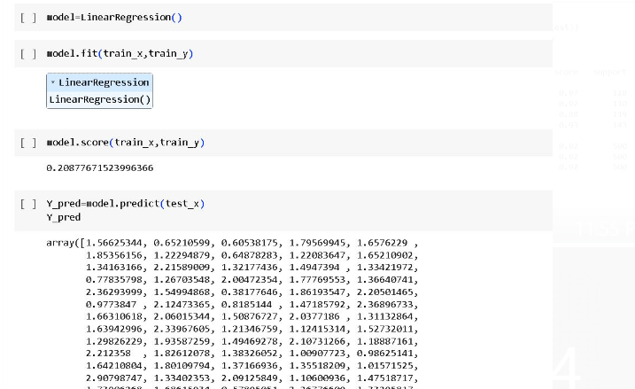

**LOGISTIC REGRESSION**

Logistic regression is a binary classification algorithm commonly used for predicting categorical outcomes. While it may not be directly applicable for predicting continuous smartphone prices, it can be utilized in a modified form to predict binary outcomes related to smartphone pricing, such as whether a smartphone will be priced above or below a certain threshold. Here's an overview of using logistic regression for smartphone price prediction:

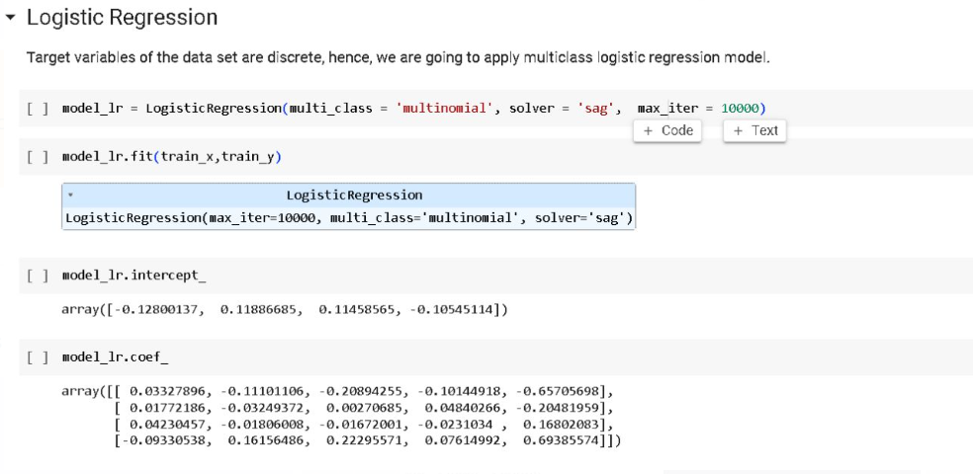

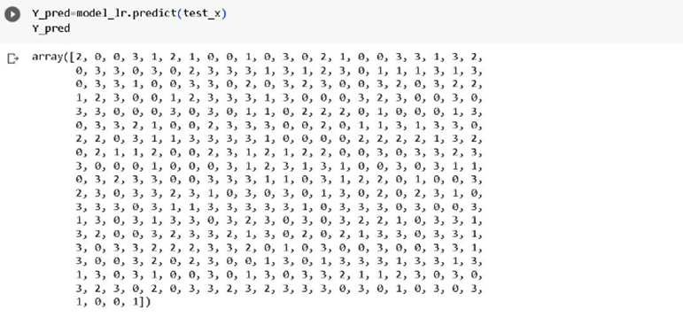

**KNN**

The k-nearest neighbors (KNN) algorithm can be used for Smartphone price prediction. KNN is a non-parametric algorithm that makes predictions based on the similarity of data points in the feature space. Here's an overview of how KNN can be applied to smart phone price prediction:

**Choosing the Value of k**: Determine the optimal value of k, which represents the number of nearest neighbors to consider for prediction. This can be done through techniques like cross-validation or grid search, where different values of k are evaluated, and the one that yields the best performance is selected.

**K Nearest Neighbor Selection**: Select the k nearest neighbors based on the calculated distances. The k closest feature vectors in the training set are considered as the neighbors.

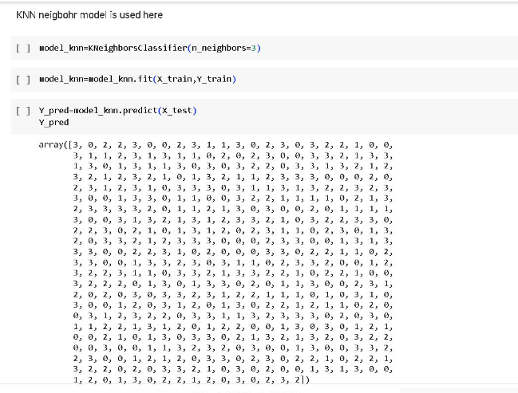

**TESTING**

**RESULT:**

**KNN**

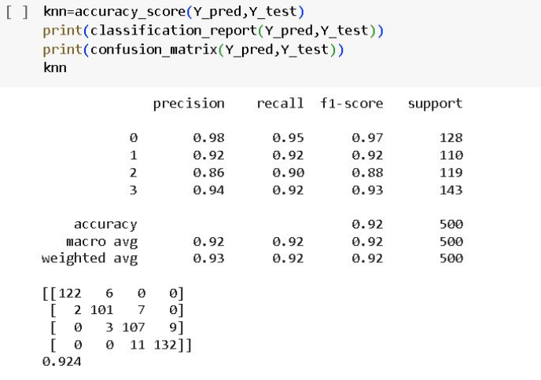

**LOGISTIC REGRESSION:**

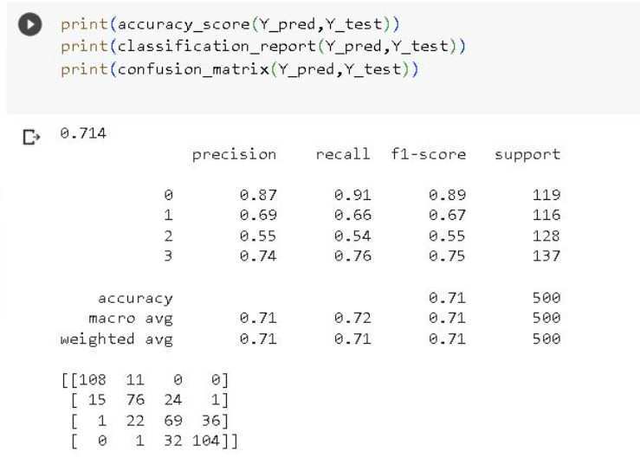

**LINEAR REGRESSION**

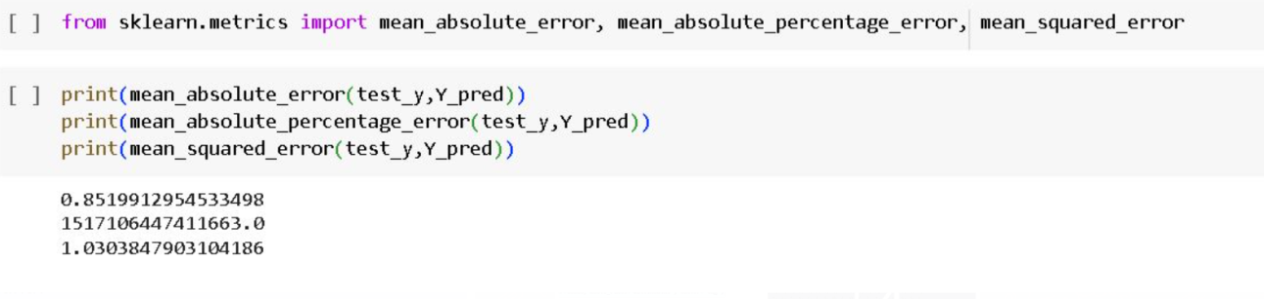

**Comparison:**

While predicting the prices **KNN** algorithm has **highest** **accuracy score**, so it is finalized to use. Accuracy for KNN is high because KNN has its limitations. It can be computationally expensive, especially with large datasets, as it requires calculating distances between instances. It also struggles with high-dimensional data, as the concept of "nearest neighbors" becomes less meaningful in higher-dimensional spaces. In addition, KNN may not perform well if the data has imbalanced class distributions or if there is irrelevant or noisy feature information.

**Conclusion:**

In this project, we reviewed machine learning approaches and their application to the field of smart phone price prediction. As the KNN model has a high accuracy so, it was finalized to use. A review of KNN has been applied to predict the prices of smart phones.

**Demo link:**

**Explanation video:**  https://youtu.be/D9G2402G1ug

**Github link:**

https://github.com/shanmukha2003/intelunnati_SH

**References:**

**1)**  Quader, N., Ganim M.O., Chaki, D., Ali, M.H.: A machine learning approach to predict movie box-office success. In: 2017 20th International Conference of Computer and Information Technology (ICCIT), pp. 1–7. IEEE (2017)

**2)** Usmani, M., Adil, S.H., Raza, K., Ali, S.S.: Stock market prediction using machine learning techniques. In: 2016 3rd International Conference on Computer and Information Sciences (ICCOINS), pp. 322–327. IEEE (2016)

**3)** https://www.kaggle.com/iabhishekofficial/mobile-price-classification#train.csv